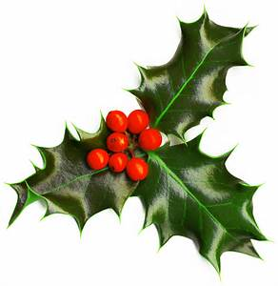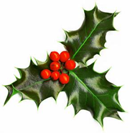******

***Save the Date!***



***Annual Christmas Craft Sale and***

***Silent Auction***

**Saturday,**

**November 25**

**9:30a.m.-2:00 p.m.**

We hope to see you and your

families come out and

experience a festive time

of crafts, food, silent auction, and of course fellowship!

Keep your eyes peeled for

posters in community businesses

and churches and check out our

Facebook page

for more updates!

***Save the Date!***



***Annual Christmas Craft Sale and***

***Silent Auction***

**Saturday, November 25**

**9:30a.m.-2:00 p.m.**

We hope to see you and your families come out and experience a festive time of crafts, food, silent auction, and of course fellowship!

Keep your eyes peeled for posters in community businesses and churches and check out our

Facebook page

for more updates!

***Save the Date!***

***Annual Christmas Craft Sale and***

***Silent Auction***

**Saturday,**

**November 25**

**9:30a.m.-2:00 p.m.**

We hope to see you and your families come out and

experience a festive time

of crafts, food, silent auction, and of course fellowship!

Keep your eyes peeled for posters in community businesses and churches and check out our

on our Facebook page

for more updates!